Anchise V1
Extraction Workflow Build Guide
Living-user, multi-account control center
Web app + local agent + Anchise cloud
Version: V1 build guide
Prepared for: Emanuele
Date: 13 April 2026
Purpose. This document puts the Anchise V1 concept into one implementation guide: customer journey, side-by-side flows, UI behavior, wireframe concepts, core architecture, stack, states, data model, security rules, and phased build plan.
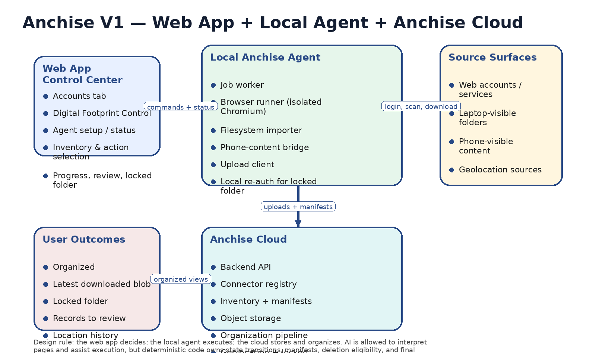
Figure 1. V1 system shape: the web app decides; the local agent executes; the cloud stores and organizes.

Document map
• Section 1 defines the V1 product and non-goals.
• Section 2 gives the exact customer journey in side-by-side form.
• Section 3 defines the user-facing features, tabs, and buttons.
• Section 4 defines the system architecture and runtime components.
• Section 5 defines connector, job, and data models.
• Section 6 defines security, privacy, geolocation, and locked-folder behavior.
• Section 7 defines the recommended stack and implementation choices.
• Section 8 defines delivery phases, testing, and shipping criteria.

1. Product statement, scope, and non-goals
Anchise V1 is a web app with a lightweight local agent. The user logs into the source accounts they choose, sees what those accounts contain at category level, downloads selected categories into Anchise cloud space, and controls the imported footprint from one place.
• The primary user is alive and well, with many digital accounts (for example 8–10 Gmail accounts plus 20–30 other apps and services).
• The product is account-centric, not identity-proof-centric. It cares that the user can access the account and wants to extract its contents.
• The V1 product surface is intentionally simple: Accounts tab + Digital Footprint Control tab + Agent setup/status.
• V1 proves connection, inventory, download, upload, organization, locked-folder, and geolocation handling. It does not attempt a full digital-will or memorial platform.

1.1 V1 success criteria
• User can create a workspace, install the agent, and pair it in one session.
• User can progressively connect many accounts instead of everything on day one.
• Before downloading, user can inspect category counts and size estimates per account.
• User can choose full or incremental import where supported, and can choose download-only or download-and-delete-source where supported.
• Downloaded content lands in Anchise cloud space and becomes visible in a two-tab control model.
• Geolocation is handled as a first-class privacy category.
• Sensitive content can be placed in a password-protected locked folder in V1.

1.2 Non-goals for V1
• No deep forensic extraction, root/jailbreak-only extraction, or hidden application sandbox capture.
• No application binary backup or cloning of installed software.
• No universal account closure promise across every service.
• No advanced V2 privacy lane where NSFW is browsed only via a local-only key and a cloud-opaque vault.
• No overdesigned AI-first state logic; AI may assist page interpretation, but deterministic code owns states and guarantees.

2. Exact customer journey — side-by-side
The table below is the operational heart of the design. The left side describes the user action; the right side describes what must happen in the background.
User does | In the background this happens
Create Anchise account | Workspace is created; empty connector registry, empty cloud vault, and default explorer areas are provisioned.
Click Set up Anchise Agent | Web app offers installer; local agent starts a secure local service; pairing token is exchanged; workspace records agent as installed/paired.
Open Accounts tab | Web app loads connector list, agent health, and the account-source creation controls.
Add a source account | Anchise creates a connector record with platform, label, profile, supported categories, and initial state = not_connected.
Click Log in for one account | Web app instructs local agent to open an isolated Chromium session for that connector; user authenticates manually.
Click Scan inventory | Agent queries the source via browser/session and returns category counts, estimated size, and capability map.
Review category inventory | Web app renders pictures, messages, files, contacts, geolocation, estimated size, and whether full/incremental and delete-after-import are supported.
Choose categories and mode | Anchise builds an import plan: categories, full/incremental, and keep/delete-source intent per account.
Click Start download | Agent downloads content, packages it into import batches, uploads it to Anchise cloud, and reports live progress.
Open Digital Footprint Control | Imported data initially appears as Latest downloaded blob, then becomes eligible for organization.
Click Organize | Organization pipeline groups content into photos, videos, documents, messages, contacts, geolocation, review bucket, and locked-folder candidates.
Open Locked folder | Re-auth or password gate is enforced; locked content stays out of default browsing and default search in V1.
Open Location history | Anchise groups geolocation by source and tracks whether source deletion was requested, confirmed, partial, or failed.
Add more accounts later | Workspace persists; connectors grow progressively; incremental sync becomes available where supported.

2.1 Journey phases
1. Workspace creation
2. Agent installation and pairing
3. Account connection
4. Inventory before download
5. Import planning
6. Download and upload
7. Organization and review
8. Locked-folder handling
9. Location-history control
10. Optional source cleanup and later closure

3. Functional model and user-facing features

3.1 Tab 1 — Accounts
The Accounts tab is the operational control room. It is where the user decides what sources exist, which ones are currently connected, what categories are present, and what action should be executed next.
• Add source: account, laptop folder, or phone-visible content
• Connection state: log in, log out, reconnect, action needed
• Inventory per source: pictures, messages, files, contacts, geolocation, total size
• Action controls: full, incremental, download, download + delete source
• Job state: scanning, downloading, uploaded, organization pending, delete eligible
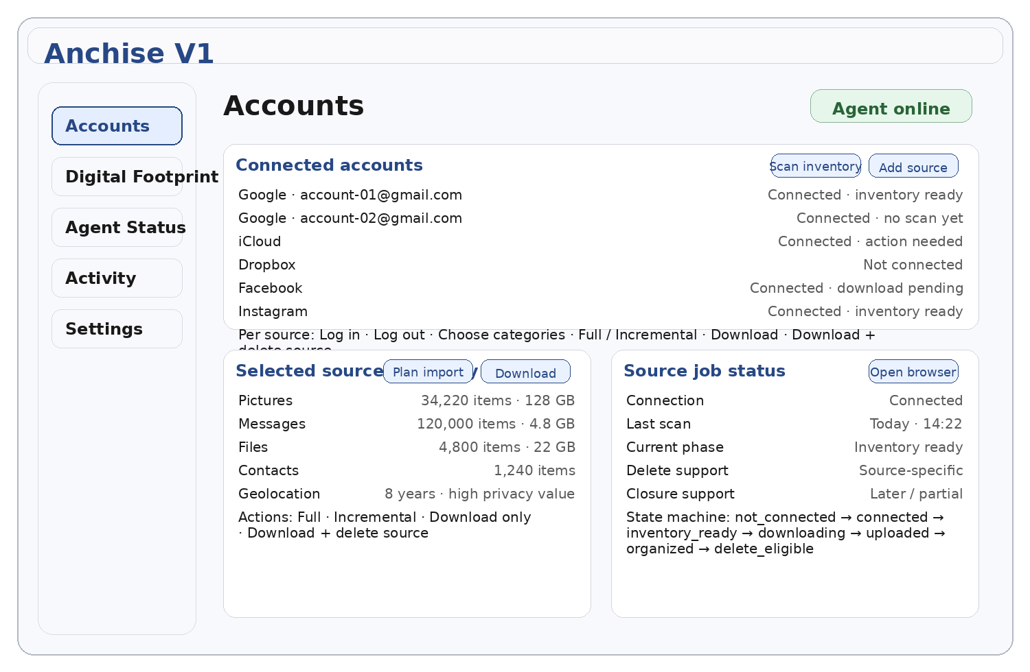
Figure 2. Accounts tab wireframe concept.

3.2 Tab 2 — Digital Footprint Control
This tab is the post-download workspace. It should feel like an intelligent explorer rather than a generic file bucket.
• Organized: ready for browsing by category, source, and time
• Latest downloaded blob: newest import batch before it has been organized
• Locked folder: password/re-auth-protected area for V1
• Records to review: ambiguous, duplicate, or uncertain items
• Location history: dedicated privacy-control view
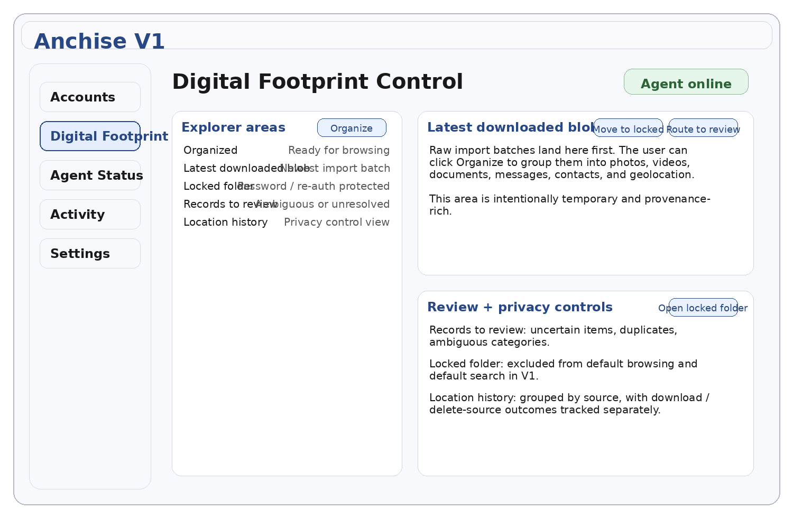
Figure 3. Digital Footprint Control wireframe concept.

3.3 Buttons and labels to lock for V1
Button / label | Purpose
Set up Anchise Agent | Installs or reconnects the local execution layer.
Add source | Creates a new account, folder, or phone-content source.
Log in | Opens the isolated Chromium session for one connector.
Log out | Invalidates the local session state for one connector.
Scan inventory | Builds the category counts and size estimate before download.
Plan import | Captures categories, mode, and source-deletion intent.
Download | Executes the selected import plan.
Download + delete source | Allowed only where connector profile supports it and only after import verification.
Organize | Runs deterministic grouping of the latest imported blob.
Move to locked folder | Moves selected items into the protected V1 folder.
Open locked folder | Prompts for re-auth or password and opens the protected area.
Reconnect agent | Repairs the web-app-to-agent local link.

3.4 Functional inventory for V1
Feature block | What it must do
Workspace | User auth, workspace creation, settings, and baseline explorer areas.
Agent setup | Download, install, pair, reconnect, update, and display health.
Connector management | One connector per source account or local source.
Inventory | Counts by category, estimated size, and capability map.
Import planning | Select categories, full/incremental, keep/delete-source intent.
Download + upload | Agent acquires locally and uploads into Anchise cloud.
Organization | Moves content from blob to organized/review/locked/location areas.
Locked folder | Password/re-auth-protected folder for V1.
Geolocation | First-class category with source-specific delete semantics.
Activity feed | User-visible job progress, action needed states, and completion history.

4. Architecture and components
Anchise V1 should be built with one clean separation of concerns: the web app decides; the local agent executes; the cloud stores and organizes. AI may assist bounded page interpretation and organization, but deterministic code owns state transitions, manifests, deletion eligibility, and final outcomes.

4.1 Component map
Component | Responsibility
Web app | Main user interface: Accounts tab, Digital Footprint Control, agent setup, progress, and settings.
Backend API | Entry point for auth, workspace state, connector records, jobs, manifests, and explorer views.
Connector registry | Stores one connector per account or local source, its capabilities, and current phase.
Job orchestrator | Schedules inventory, download, organize, and source-delete jobs.
Local agent | Receives commands, launches browser sessions, reads local files, bridges phone-visible content, uploads artifacts.
Browser runner | Isolated Chromium profile(s) for account login and browser-side acquisition.
Filesystem importer | Imports approved laptop folders and already-downloaded archives.
Phone-content bridge | Handles phone-visible content where the OS makes it available to the user and agent.
Object storage | Holds raw imports, organized objects, locked-folder objects, and geolocation artifacts.
Manifest service | Tracks import batches, chunks, provenance, and verification state.
Organization pipeline | Moves imported blobs into organized structures, review queues, and locked-folder candidates.
Geolocation module | Groups location data by source and tracks deletion outcomes.

4.2 Recommended deployment shape
• Frontend: React / Next.js web app.
• Backend: Node.js TypeScript API service with a relational database and object storage.
• Local agent: desktop application or background daemon with a small local secure service.
• Browser execution: Playwright driving isolated Chromium profiles or a comparable browser-control layer.
• Uploads: resumable protocol such as tus for large libraries and weak-network recovery.
• Storage: S3-compatible object storage for durable imported artifacts.

4.3 Design rules to keep the system sane
• Account-centric model: the user chooses sources and controls them through Anchise; do not overbuild identity proofing into the product core.
• Progressive connection: support many accounts but do not force all accounts to be connected on day one.
• Inventory before download: the user should not import blindly.
• Browser/session-first connector execution: APIs can help, but do not make them the only acquisition path.
• Source-specific delete semantics: never pretend that every service supports the same delete or closure guarantees.

5. Data model, connector model, and states

5.1 Core entities
Entity | Meaning
Workspace | Top-level user space containing connectors, imports, organized views, and settings.
Connector | A source account or local source. Examples: Google account 1, iCloud, Dropbox, laptop folder, phone-visible content.
InventorySnapshot | Category counts, estimated size, and capability map for one connector at one point in time.
ImportPlan | Selected categories, full/incremental mode, and keep/delete-source intent.
ImportBatch | Resulting acquired unit(s) uploaded by the agent.
Manifest | Provenance and verification record for uploaded objects and chunks.
ExplorerItem | User-visible object or grouped object inside Organized / Blob / Locked / Review / Location views.
LocationImport | Geolocation artifacts grouped by source and tracked with source-delete outcomes.

5.2 Connector state machine
Connector state | Meaning
not_connected | Source exists as a planned connector but no valid session is present.
connected | Session is valid and the connector is ready for inventory or execution.
inventory_ready | Inventory exists and the user can plan imports.
download_pending | Import plan exists and waits for execution.
downloading | Agent is currently acquiring data and/or uploading it to cloud.
uploaded | Agent upload completed for the current batch.
organization_pending | Data exists but has not yet been organized.
organized | Latest imported data has been grouped into explorer structures.
delete_eligible | Import verification succeeded and source-deletion action may be offered.
delete_in_progress | Source deletion or cleanup action is running.
action_needed | Re-authentication or manual follow-up is needed.

5.3 Import-batch lifecycle
1. User creates or triggers an import plan.
2. Job orchestrator hands the plan to the local agent.
3. Agent acquires data from source account or local surface.
4. Agent packages data with provenance into one or more import batches.
5. Agent uploads batches to Anchise cloud using resumable upload.
6. Manifest service verifies expected content and marks the batch complete or incomplete.
7. Organization pipeline can now route the batch into blob, organized, review, locked, and geolocation areas.

5.4 Side-by-side for import states
State shown to user | What the system has verified
Connected | A valid source session exists and the connector can act.
Inventory ready | Counts and capability map are available to the user.
Download pending | Import plan is waiting to run.
Downloading | Acquisition or upload is in progress.
Uploaded | Raw batch exists in cloud storage.
Organization pending | Batch has not yet been grouped into the explorer.
Organized | Batch has been transformed into user-facing explorer structures.
Delete eligible | Source-deletion action may now be offered, subject to source support.

6. Extraction workflow in detail
This section defines the exact extraction workflow the engineering team should build first.

6.1 Acquisition surfaces
• Browser/account surface: for accounts reached through a real login session.
• Laptop filesystem surface: for folders, exports, and user-visible local content.
• Phone-visible content surface: for files, photos, contacts, calendar, and other user-visible data the OS makes available.

6.2 Category model
Category | V1 meaning
Pictures | Photos and images from account exports, cloud stores, laptop folders, or phone-visible media.
Messages | Email or message-like content where the source makes it available.
Files | Documents, archives, and user files.
Contacts | Address-book style records.
Geolocation | Timeline, trip, place, or geotagged location-bearing data.

6.3 Full vs incremental
• Full import means Anchise attempts to bring the complete selected category under control.
• Incremental import means Anchise attempts to fetch only new or changed items since the last good checkpoint.
• Connector profiles must declare whether incremental import is actually supported; the UI should never pretend it is universal.

6.4 Download-only vs download-and-delete-source
• Download only means Anchise copies content into Anchise cloud space and leaves the source unchanged.
• Download + delete source means Anchise asks the connector runtime to delete the source-side category only after the import has been verified.
• Delete capability must be labeled source-specifically: direct delete supported, deletion request supported, account deletion only, or download only.

6.5 Why inventory is not optional
Inventory is the product feature that turns Anchise from a blind scraper into a control center. It allows the user to decide, per account and category, whether an import is worth running, how much cloud space it will likely consume, whether incremental mode exists, and whether source deletion should be attempted later.

7. Geolocation as a first-class privacy category
Geolocation is not just another file type. In Anchise, it is a privacy-control category with its own view and source-specific delete semantics.
• Treat geolocation as a top-level category in inventory and planning.
• Group geolocation by source: timeline, trips, saved places, delivery addresses, photo geotags, and phone-local significant locations.
• Track delete outcomes separately from import outcomes.
• Provide a dedicated Location history view in Tab 2.
User geolocation action | System behavior
Download only | Copy location-bearing data into Anchise cloud, do not touch source.
Download + request delete | Import successfully, then submit deletion request where the source supports only a request pattern.
Download + verified delete | Import successfully, then execute a source-side delete flow where strong confirmation exists.
Pause geolocation intake | Do not import or refresh this category for the connector until the user changes it.

8. Locked folder for V1
V1 keeps the locked folder simple. It is a password or re-auth protected area inside Anchise. It is not yet the advanced V2 local-only private lane with a separate local key domain.
• Locked content is excluded from default browsing and default search until explicitly opened.
• The user can move selected items into the locked folder from Organized or from the latest blob.
• The locked folder is suitable for sensitive content in V1, but it should be deliberately lightweight so V1 can ship.
Mode | Definition
V1 locked folder | Password/re-auth protected, encrypted at rest, cloud-hosted, hidden from default browsing and search.
V2 private lane (future) | Local-only key domain, opaque cloud backup, local rendering through the agent, no operator readability.

9. Security and privacy rules
• The web app is the control plane; it should not directly own local browser or filesystem execution.
• The local agent is the execution plane; it handles browser automation, local file access, and uploads.
• Anchise cloud stores imported artifacts, manifests, and explorer state; it should not require raw source credentials in the cloud to operate.
• AI can interpret pages and help execution, but deterministic code must own job states, manifests, and source-delete eligibility.
• Applications themselves are out of scope; Anchise imports user content, not software binaries or hidden system internals.

9.1 Recommended V1 credential handling
• Use isolated browser profiles for source logins.
• Prefer manual login by the user inside the popup browser session.
• Keep session state scoped to one connector or one account lane where practical.
• Do not let the cloud become a general password wallet if it can be avoided in V1.

10. Stack recommendation
The stack below is recommended because it aligns with the product shape: a web control center, a local agent, browser automation, resumable uploads, and durable cloud storage.
Layer | Recommended choice | Why
Web app | React / Next.js | Good fit for a rich two-tab workspace, status views, and account control.
Backend API | Node.js + TypeScript | Matches real-time control APIs and a browser-oriented execution platform.
Database | PostgreSQL | Good fit for workspaces, connectors, manifests, jobs, and explorer metadata.
Object storage | S3-compatible bucket | Durable destination for imported batches and organized artifacts.
Uploads | tus or equivalent resumable upload layer | Required for large photo/video libraries and weak-network recovery.
Local agent | Desktop process with local secure service | Acts as the execution muscle on the user machine.
Browser automation | Playwright controlling isolated Chromium | Strong fit for real browser automation and agent workflows.
Bounded AI runtime | Qwen-Agent or equivalent tool-calling framework | Useful for adaptive page interpretation and task execution without making AI the source of truth.

10.1 Stack rationale to lock
• Choose browser automation that works with real Chromium profiles and supports structured automation. Playwright is a strong fit because it can drive Chromium directly and gives the team one stable browser-control surface for V1.
• Choose a bounded agent framework rather than inventing your own execution semantics. A Qwen-Agent style tool-calling layer is a good fit for adaptive page interpretation and task execution, but it should remain subordinate to deterministic connector and manifest logic.
• Use resumable uploads as a hard requirement, not a nice-to-have. A tus-style resumable upload layer is the right shape for large photo and video libraries, unstable home networks, and long-running imports.

11. API and local command sketch
V1 does not need a huge API surface, but it does need clear boundaries.
Endpoint / command | Purpose
POST /workspace/agent/pair | Pair the browser session with a local agent instance.
POST /connectors | Create a connector for an account or local source.
POST /connectors/{id}/login/start | Ask the local agent to open an isolated browser lane.
POST /connectors/{id}/inventory | Start an inventory job.
POST /connectors/{id}/plan-import | Persist categories, mode, and delete intent.
POST /connectors/{id}/download | Launch an import job through the local agent.
POST /organize | Organize one or more latest imported blobs.
POST /locked-folder/move | Move selected items into the locked folder.
GET /workspace/status | Return connector states, agent status, jobs, and summary counts.

11.1 Local agent commands
Agent command | Function
openBrowserForConnector | Launch isolated Chromium for one connector.
scanInventory | Return category counts, estimated size, and capability map.
runImport | Acquire selected categories and upload batches.
importLocalFolder | Package laptop-visible folders and upload them.
importPhoneVisibleContent | Acquire approved phone-visible categories and upload them.
moveToLockedFolder | Apply V1 locked-folder movement locally or via cloud command.
reportProgress | Push status updates back to backend and UI.

12. Build plan

12.1 Phase 1 — core shell
• Web app auth, workspace creation, and empty two-tab shell
• Agent setup/download/pairing flow
• Connector registry and agent status module

12.2 Phase 2 — browser accounts
• Isolated browser login flow for first few connectors
• Inventory engine
• Import planning UI and job states

12.3 Phase 3 — storage and explorer
• Import batches, manifests, object storage, and latest blob view
• Organization pipeline and organized explorer
• Locked folder V1

12.4 Phase 4 — geolocation and source deletion
• Dedicated location-history view
• Source-specific delete outcome model
• First few delete-enabled flows where confidence is strong

13. QA and shipping criteria
QA area | Shipping requirement
Agent pairing | Fresh install, reconnect, offline, update-needed states render correctly.
Multi-account login | User can add several source accounts without cross-account contamination.
Inventory accuracy | Counts and estimated sizes are sensible and stable after refresh.
Resumable upload | Interrupted large imports resume without duplicate finalization.
Explorer routing | Blob, Organized, Locked, Review, and Location areas update correctly.
Geolocation | Location imports are visible separately and delete outcome states are explicit.
Locked folder | Protected content is hidden by default and accessible only after re-auth.

13.1 Side-by-side validation checklist
User action to test | What must be true
User logs in to Anchise | Workspace and agent status are shown immediately.
User adds 5–10 accounts progressively | Each source appears as a separate connector with clear state.
User scans one account | Inventory appears before any destructive or expensive import starts.
User downloads selected categories | Live progress is visible and imported data lands in cloud storage.
User clicks Organize | Content moves from blob to organized structures without losing provenance.
User opens Location history | Imported location data is visible as a separate privacy-control view.

14. V1 decisions to lock now
1. Anchise V1 is a web app plus a lightweight local agent.
2. The web app is the main product surface; the agent is the execution layer.
3. The two primary tabs are Accounts and Digital Footprint Control.
4. Inventory before download is mandatory.
5. Geolocation is a first-class category.
6. Applications themselves are out of scope; user content is in scope.
7. The V1 locked folder is protected but intentionally simple.
8. AI may execute bounded adaptive tasks, but code decides states and guarantees.

15. Open questions that can wait until after V1
• How much of source deletion and closure should be automated versus manual in early releases?
• How much phone-visible content can be imported cleanly without a companion app?
• Which first 5–8 connectors should ship in Wave 1?
• How far should V1 organization go before AI-assisted classification becomes worth the complexity?
• When should the locked folder evolve into the stronger V2 private lane?

Appendix A — one-page operating principle
USER WORKSPACE
|
+-- Web App (control plane)
| +-- Accounts tab
| +-- Digital Footprint Control
| +-- Agent setup / status
|
+-- Local Agent (execution plane)
| +-- Popup Chromium login
| +-- Inventory
| +-- Download
| +-- Local import surfaces
| +-- Upload to Anchise cloud
|
+-- Anchise Cloud
+-- Connector registry
+-- Import manifests
+-- Object storage
+-- Organized explorer
+-- Locked folder
+-- Location history
Rule:
The web app decides.
The local agent executes.
The cloud stores and organizes.
AI may assist.
Code guarantees.

